Title
Radiation-Based Central Air Conditioning System with Integrated Solar Heat Collection and Related Methods

TECHNICAL FIELD
[0001] The present disclosure relates to a radiation-based central AC system with integrated solar heat collection and efficient cooling/heating using CO2 as a single-stage working medium.

BACKGROUND
[0002] In recent years, the demand for energy-efficient and environmentally friendly heating, ventilation, and air conditioning (HVAC) systems has been on the rise. Traditional HVAC systems, which often rely on refrigerants like Freon or ammonia, are known for their high energy consumption and environmental impact, particularly in terms of greenhouse gas emissions. These systems also tend to have reduced heating efficiency during colder months, which can lead to increased energy usage and higher costs for consumers. As a result, there is a growing need for innovative solutions that can provide effective climate control while minimizing environmental impact.
[0003] Renewable energy sources, such as solar energy, present a promising avenue for addressing these challenges. Solar energy is abundant, sustainable, and has the potential to significantly reduce the carbon footprint of HVAC systems. However, integrating solar energy into traditional HVAC systems has proven to be complex, with issues related to efficiency and consistency of energy supply. The development of systems that can effectively harness solar energy for heating and cooling purposes, while maintaining high efficiency and reliability, is crucial for advancing sustainable building technologies. This need for improved integration of renewable energy into HVAC systems drives the exploration of new technologies and approaches in the field.

SUMMARY
[0004] The radiation-based central AC system may include a solar heat collection unit that is integrated with the central AC system to provide efficient cooling and heating. The system can use CO2 as a single-stage working medium. The outdoor unit may have a radiation heat collector, which can include a plate core, an absorption plate, and a protection plate. The indoor unit may consist of multiple indoor heat exchangers arranged in layers and several adjustable throttling valves for temperature regulation. The compressor unit may include a compressor, an accumulator, and several reversing valves, which can drive refrigerant circulation and enable switching between heating and cooling modes.
[0005] The outdoor unit of the radiation-based central AC system may also include a flash heat exchanger with water atomization to improve efficiency.
[0006] The plate core of the radiation heat collector may consist of a serpentine coil or a fluid passage.
[0007] The absorption plate in the radiation heat collector can function as a solar collector.
[0008] The flash heat exchanger in the outdoor unit may include a shell, a heat exchange unit, a water atomization device, a fan, and a medium flow pipe.
[0009] The adjustable throttling valves in the indoor unit may allow for controlled cooling and heating distribution across multiple floors.
[0010] The compressor in the compressor unit may compress the CO2 working fluid.
[0011] The accumulator in the compressor unit can stabilize refrigerant storage.
[0012] The reversing valves in the compressor unit may include a first four-way reversing valve and a second four-way reversing valve to direct refrigerant flow for heating or cooling.
[0013] The radiation-based central AC system may also include several electromagnetic valves to control flow between the radiation heat collector and the flash heat exchanger.
[0014] A one-way valve may be included in the radiation-based central AC system to prevent backflow.
[0015] The method for providing efficient cooling and heating using a radiation-based central AC system may involve integrating a solar heat collection unit with the central AC system to use CO2 as a single-stage working medium. Solar heat can be collected using a radiation heat collector in an outdoor unit, which may include a plate core, an absorption plate, and a protection plate. Cooling or heating can be distributed through multiple indoor heat exchangers arranged in layers in an indoor unit. Temperature regulation may be achieved using several adjustable throttling valves in the indoor unit. Refrigerant circulation can be driven by a compressor unit that may include a compressor, an accumulator, and several reversing valves. The compressor unit may also enable switching between heating and cooling modes.
[0016] The method may further improve efficiency by utilizing a flash heat exchanger with water atomization in the outdoor unit.
[0017] The plate core in the radiation heat collector may consist of a serpentine coil or a fluid passage.
[0018] The absorption plate in the radiation heat collector can function as a solar collector.
[0019] The flash heat exchanger in the outdoor unit may include a shell, a heat exchange unit, a water atomization device, a fan, and a medium flow pipe.
[0020] The method may also enable controlled cooling and heating distribution across multiple floors using the adjustable throttling valves.
[0021] The CO2 working fluid may be compressed using the compressor.
[0022] Refrigerant storage can be stabilized using the accumulator.
[0023] Refrigerant flow for heating or cooling may be directed using a first four-way reversing valve and a second four-way reversing valve in the compressor unit.

LIST OF FIGURES
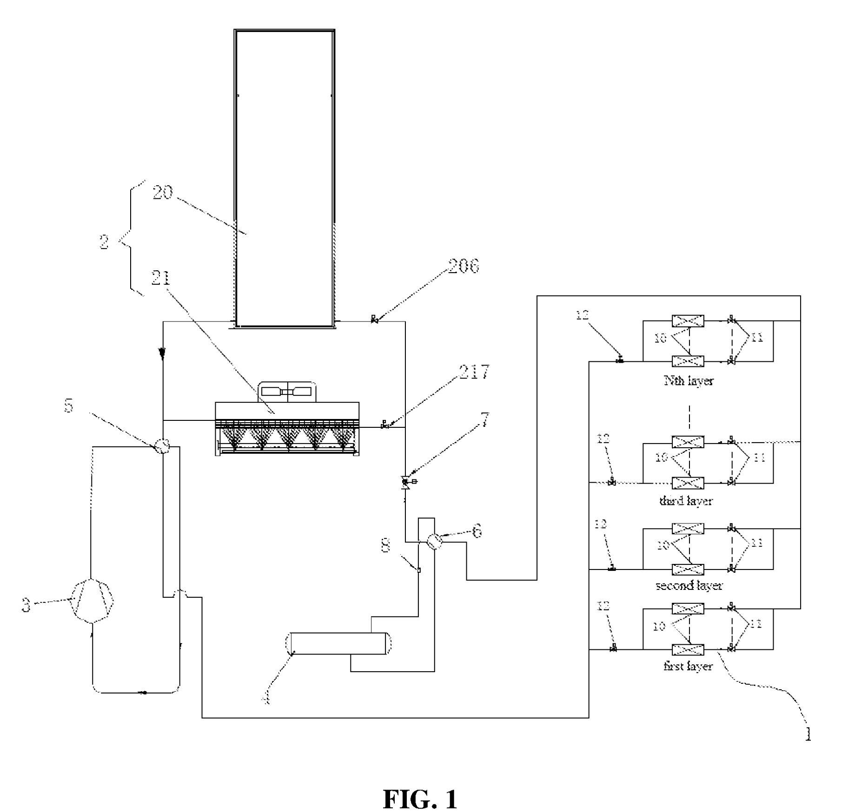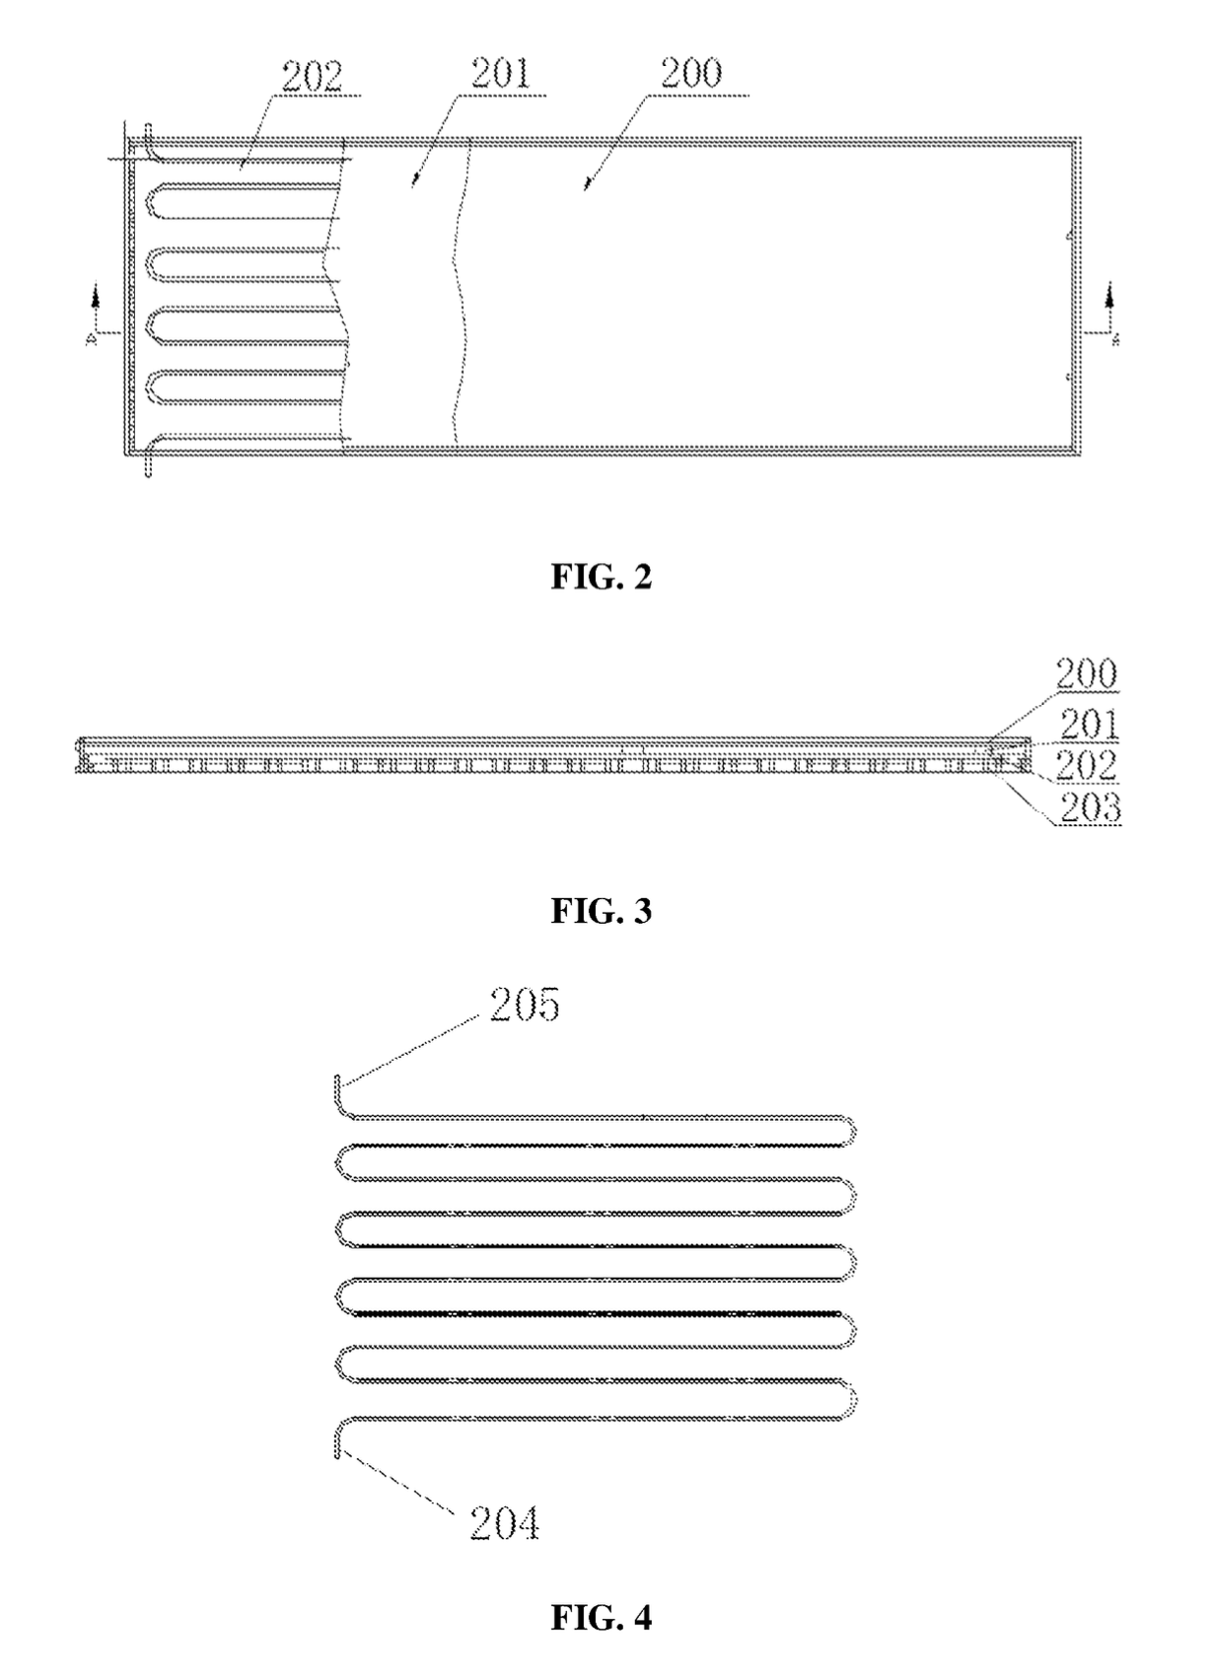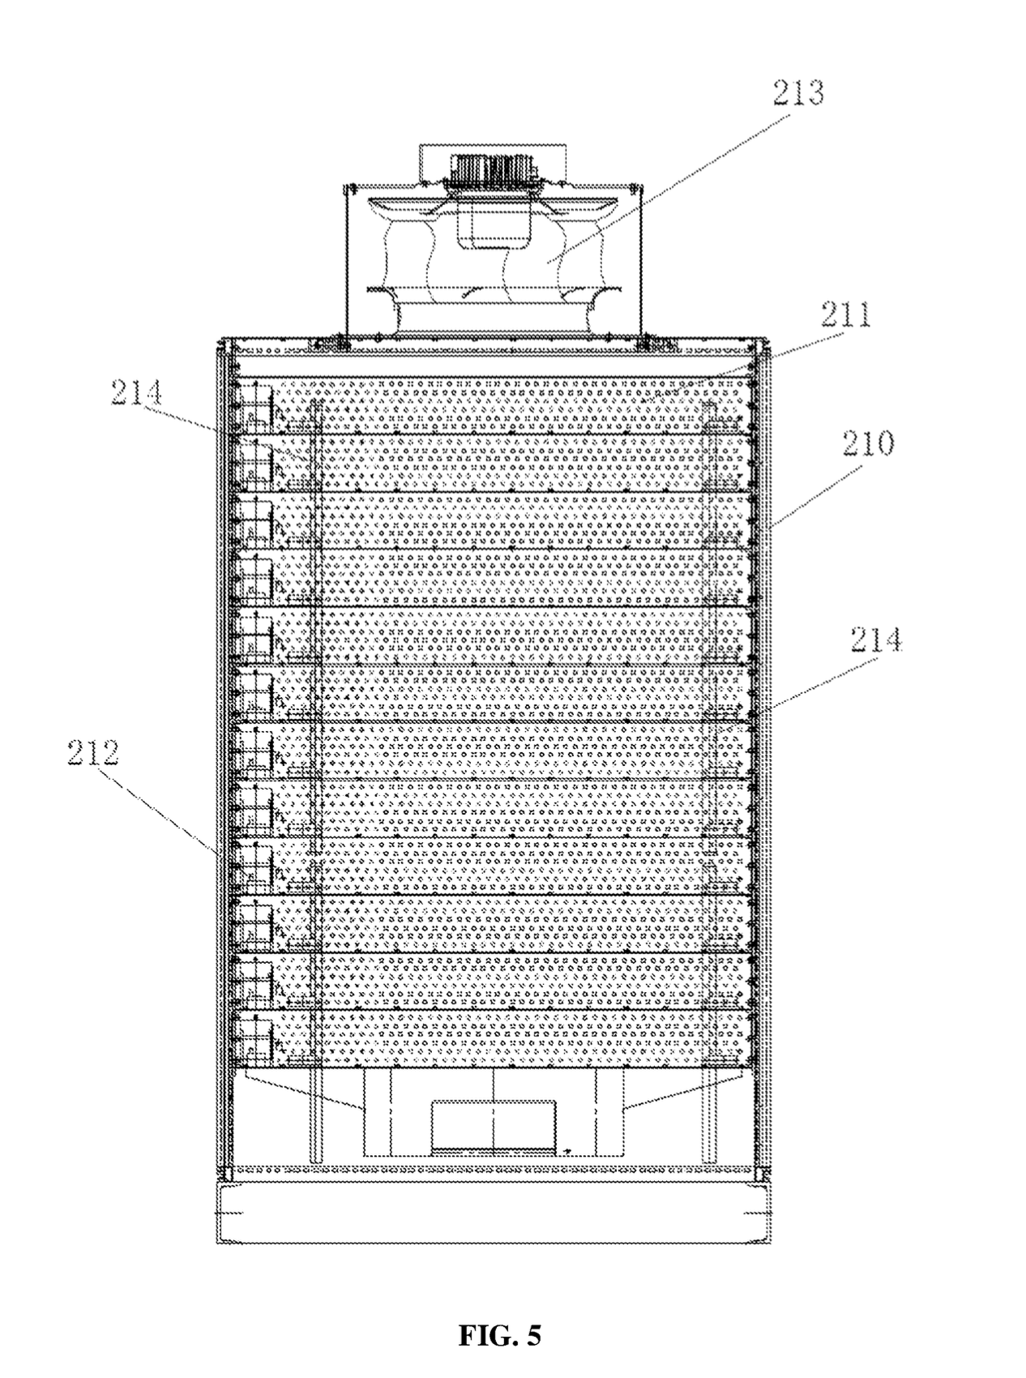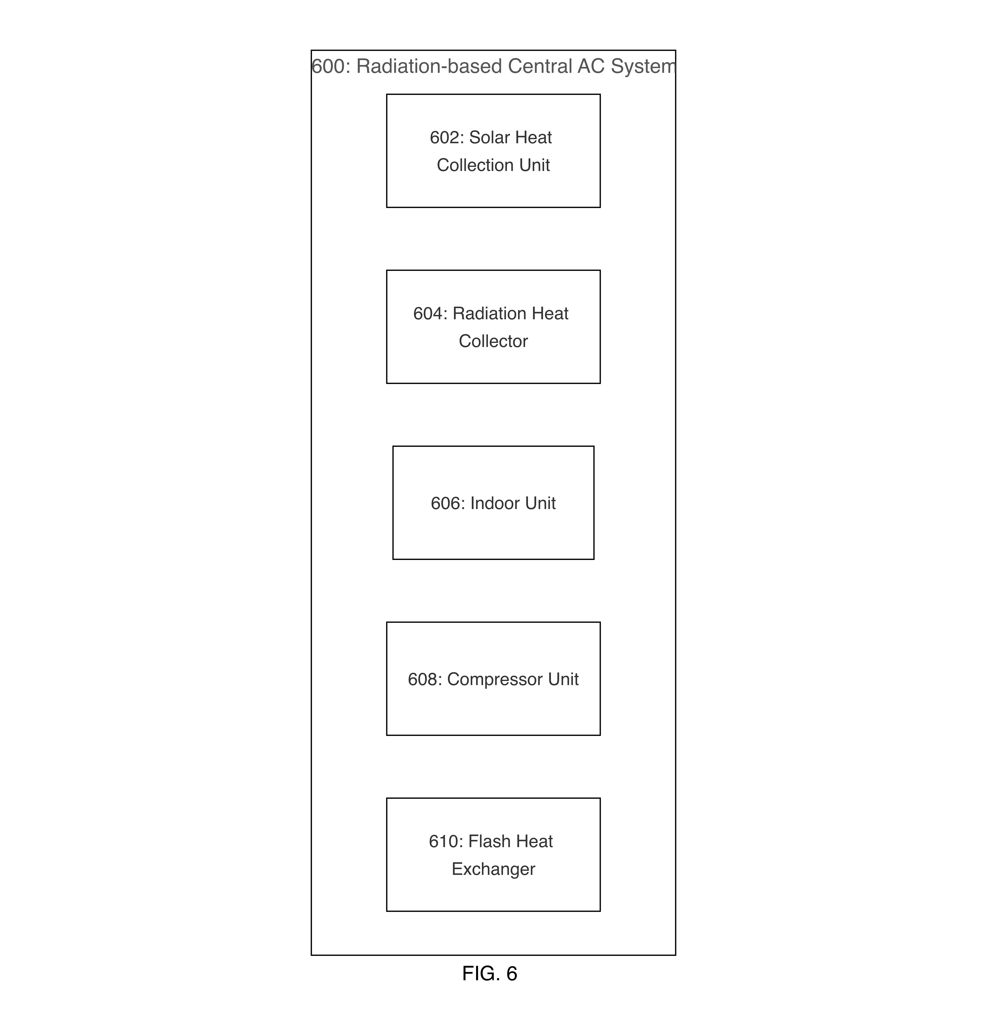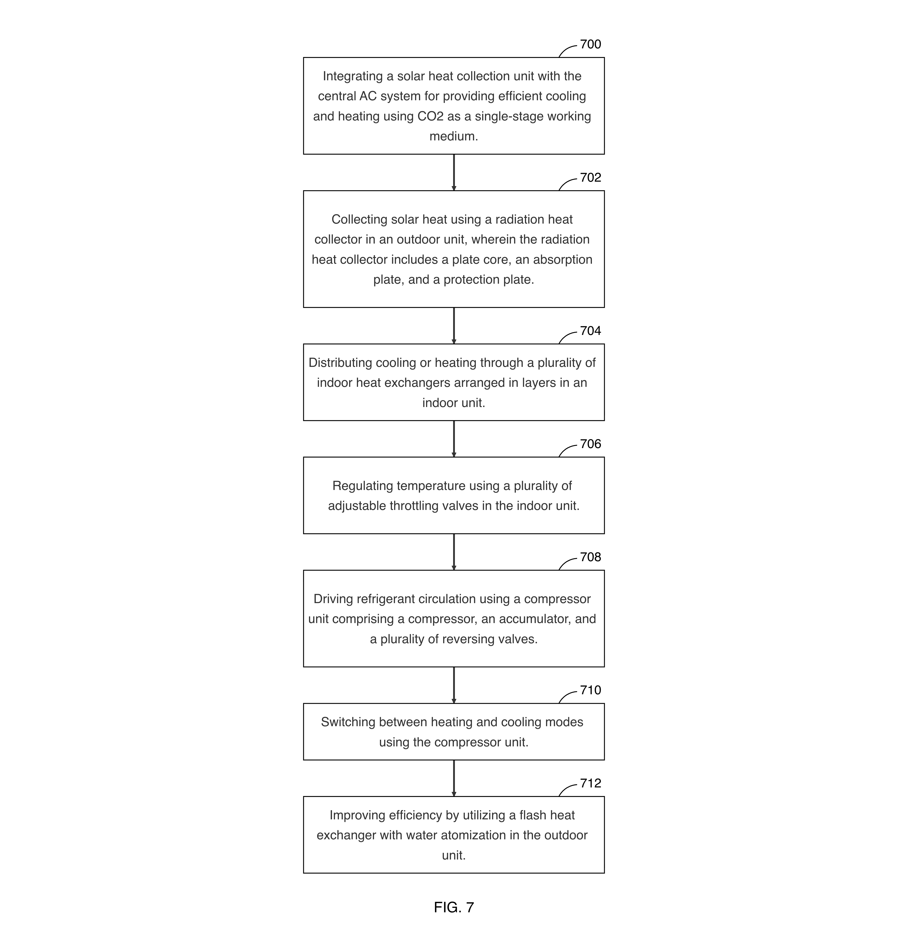
FIG. 1 is a schematic diagram of the overall radiation-based central AC system, showing the interconnection of the indoor unit (1), outdoor unit (2), compressor (3), and accumulator (4).
FIG. 2 is a top plan view showing the internal structure of the radiation heat collector (200), including the heat absorption plate (201) and the plate core (202).
FIG. 5 is a structural diagram of the flash heat exchanger, showing the shell (210), heat exchange unit (211), water atomization device (212), fan (213), and medium flow pipe (214).
FIG. 6 illustrates components of a radiation-based central AC system.
FIG. 7 illustrates integrating solar heat collection with central AC for efficient heating and cooling using CO2.

DETAILED DESCRIPTION
[0024] The disclosure provides a radiation-based central AC system that integrates solar heat collection for efficient cooling and heating using CO2 as a single-stage working medium. The system includes an outdoor unit with a radiation heat collector, which consists of a plate core, an absorption plate, and a protection plate, and may feature a flash heat exchanger with water atomization to enhance efficiency. An indoor unit is equipped with multiple indoor heat exchangers arranged in layers and throttling valves to regulate temperature distribution across various floors. A compressor unit, comprising a compressor and an accumulator, drives refrigerant circulation and enables switching between heating and cooling modes through reversing valves. The system incorporates electromagnetic valves to control flow between the radiation heat collector and the flash heat exchanger, and a one-way valve to prevent backflow, ensuring efficient operation and temperature regulation using renewable energy.
[0025] Referring now to FIG. 1, the schematic diagram of the radiation-based central AC system is depicted, illustrating the integration and interaction of its various components. The system comprises an indoor unit (1) that features a multi-layer arrangement of indoor heat exchangers (10) and throttling valves (11). These components facilitate climate control across multiple floors, allowing for distribution of cooling or heating as needed. The indoor heat exchangers (10) are strategically layered to optimize thermal exchange, while the throttling valves (11) regulate the flow of the refrigerant, thereby enabling tailored temperature settings for different zones within a building. This configuration enhances the system's adaptability to varying thermal demands, ensuring comfort and energy efficiency.
[0026] The outdoor unit (2) is equipped with a radiation heat collector (20) and a flash heat exchanger (21). The radiation heat collector (20) includes a plate core, an absorption plate, and a protection plate to harness solar energy effectively. This collector captures and converts solar radiation into thermal energy, which is then utilized by the system to reduce reliance on conventional energy sources. The flash heat exchanger (21) enhances the system's efficiency by incorporating a shell, heat exchange unit, water atomization device, fan, and medium flow pipe. These components work together to improve heat transfer, particularly under variable sunlight conditions, by ensuring that the heat exchange process is both rapid and effective.
[0027] The compressor unit, comprising a compressor (3) and an accumulator (4), plays a role in driving the refrigerant circulation throughout the system. The compressor (3) compresses the CO2 working fluid, which allows for a single-stage working medium that is both environmentally friendly and efficient. The accumulator (4) stabilizes refrigerant storage, ensuring a consistent supply of refrigerant to the system and preventing fluctuations that could affect performance. Additionally, the system includes a first four-way reversing valve (5) and a second four-way reversing valve (6), which enable the switching between heating and cooling modes. These valves direct the flow of refrigerant, allowing the system to adapt to seasonal changes and user preferences seamlessly.
[0028] Further enhancing the system's functionality are the one-way valve (7) and the electromagnetic valve (8). The one-way valve (7) prevents backflow, ensuring that the refrigerant flows in the intended direction, thereby maintaining system efficiency and preventing potential damage. The electromagnetic valve (8) controls the flow of refrigerant between the radiation heat collector and the flash heat exchanger, allowing for precise management of the thermal exchange process. This level of control is essential for optimizing the system's performance and ensuring that it operates at peak efficiency under varying environmental conditions.
[0029] In summary, FIG. 1 provides an overview of the radiation-based central AC system, highlighting the interconnection and interaction of its components. The indoor and outdoor units, along with the compressor and accumulator, work in concert to deliver cooling and heating. The integration of solar heat collection and advanced heat exchange technologies underscores the system's commitment to sustainability and energy efficiency.
[0030] Referring now to FIG. 2, the illustration provides a detailed top plan view of the radiation heat collector (200), a component of the radiation-based central AC system. This figure reveals the internal structure of the radiation heat collector, showcasing its integral parts designed to harness solar thermal energy efficiently. The radiation heat collector (200) is depicted with a partial cutaway to expose its internal components, specifically highlighting the heat absorption plate (201) and the plate core (202). The heat absorption plate (201) is strategically positioned over the plate core (202), which is designed to contain fluid passages for the working medium, CO2. This configuration is essential for the collection and transfer of solar thermal energy, which is a cornerstone of the system's operation.
[0031] The heat absorption plate (201) functions as a solar collector, capturing solar energy and transferring it to the plate core (202). The plate core (202) is described as having a serpentine coil or fluid passage, which facilitates the movement of the working medium through the collector, allowing for heat exchange. This design is crucial for maximizing the absorption of solar energy and its conversion into thermal energy, which can then be utilized for both heating and cooling purposes within the central AC system. The integration of these components ensures that the system can operate efficiently, leveraging renewable solar energy to reduce reliance on traditional energy sources and improve overall energy efficiency.
[0032] In terms of structural relationships, the heat absorption plate (201) is directly mounted on the plate core (202), ensuring thermal contact and energy transfer. The positioning of these components allows the system to capture and utilize solar energy. The radiation heat collector (200) is part of the outdoor unit, which may also include a flash heat exchanger with water atomization for enhanced efficiency. This setup allows the system to adapt to varying sunlight conditions, maintaining performance. The interaction between the heat absorption plate (201) and the plate core (202) is fundamental to the system's ability to switch between heating and cooling modes, as facilitated by the compressor unit and reversing valves. This interaction ensures that the system can provide controlled cooling and heating distribution across multiple floors.
[0033] Referring now to FIG. 5, the detailed structural view of the flash heat exchanger is depicted, which is an integral component of the radiation-based central AC system. This figure illustrates the flash heat exchanger's configuration, which enhances the system's efficiency by utilizing water atomization to improve heat transfer. The flash heat exchanger comprises an outer shell (210), which serves as the primary housing for the internal components, providing structural integrity and protection from external elements. The shell is constructed from durable materials capable of withstanding environmental conditions and the operational pressures of the system.
[0034] Within the shell (210), the heat exchange unit (211) is positioned, which facilitates the transfer of heat between the working medium and the surrounding environment. This unit is designed with a series of coils or plates that maximize surface area contact, thereby optimizing the heat exchange process. The water atomization device (212) is strategically integrated into the system to spray a fine mist over the heat exchange surfaces, which enhances the heat transfer efficiency by increasing the surface area for evaporation and cooling. This device is crucial in maintaining performance under varying sunlight conditions, as it allows for rapid heat dissipation.
[0035] Mounted at the top of the flash heat exchanger is a fan (213), which is responsible for driving airflow across the heat exchange unit. The fan is configured to operate at variable speeds, allowing for adjustments based on the system's cooling or heating demands. This airflow is essential for maintaining a temperature gradient across the heat exchange surfaces, thereby facilitating heat transfer. The medium flow pipe (214) is another component, providing a conduit for the working medium, such as CO2, to circulate through the heat exchange unit. This pipe is designed to accommodate the high pressures and temperatures associated with the system's operation, ensuring reliable and continuous flow.
[0036] The structural relationships among these components are pivotal for the flash heat exchanger's functionality. The shell (210) not only houses the internal components but also supports the fan (213) and water atomization device (212), ensuring they are optimally positioned for operation. The heat exchange unit (211) is centrally located within the shell to maximize exposure to the airflow generated by the fan and the mist from the atomization device. The medium flow pipe (214) is integrated into the heat exchange unit, allowing the working medium to absorb or release heat as it circulates.
[0037] In the context of the system, the flash heat exchanger's role is to improve the overall efficiency of the radiation-based central AC system by enhancing heat transfer capabilities. This is particularly important in scenarios where solar energy is variable, as the water atomization device can compensate for fluctuations in sunlight by maintaining cooling or heating. The interaction between the fan, water atomization device, and heat exchange unit ensures that the system can adapt to changing environmental conditions, thereby providing consistent performance. This integration of components emphasizes the use of renewable energy sources and innovative heat exchange techniques to achieve cooling and heating.
[0038] FIG. 6 illustrates the solar heat collection unit, which is integrated into a radiation-based central AC system. The solar heat collection unit is responsible for collecting solar heat, which can be used to provide cooling and heating. This unit works in conjunction with the radiation heat collector, which includes a plate core, an absorption plate, and a protection plate. These components collectively function to collect and absorb solar heat, thereby enhancing the system's efficiency. The solar heat collection unit is integrated with the central AC system to facilitate cooling and heating using CO2 as a single-stage working medium. The integration allows for the control of flow between the radiation heat collector and the flash heat exchanger, which may be optional for improved efficiency. The flash heat exchanger includes a shell, a heat exchange unit, a water atomization device, a fan, and a medium flow pipe, all of which contribute to heat transfer under variable sunlight conditions. The solar heat collection unit is a component in ensuring that the system can utilize renewable energy effectively, thereby providing a sustainable solution for temperature regulation. The system also includes electromagnetic valves to control the flow between the collector and the exchanger, and a one-way valve to prevent backflow, ensuring the system operates efficiently.
[0039] The Radiation Heat Collector component 604 serves as an element in the radiation-based central AC system. This component is responsible for collecting and absorbing solar heat, which is achieved through its sub-components: the plate core, absorption plate, and protection plate. The plate core includes a serpentine coil or fluid passage, which facilitates the transfer of solar energy. The absorption plate, functioning as a solar collector, captures solar radiation, while the protection plate safeguards the internal components from environmental factors.
[0040] The Radiation Heat Collector is integrated into the outdoor unit of the system, where it works in conjunction with other components to optimize the system's performance. The collected solar heat is utilized to enhance the efficiency of the central AC system, providing both cooling and heating capabilities. The integration of this component allows the system to use CO2 as a single-stage working medium, which contributes to the system's overall efficiency and sustainability.
[0041] In the context of the system, the Radiation Heat Collector is designed to work seamlessly with the flash heat exchanger, which includes a water atomization device for improved heat transfer efficiency. This collaboration ensures that the system can adapt to variable sunlight conditions, maintaining performance.
[0042] The actions associated with the Radiation Heat Collector, such as collecting solar heat and comprising a plate core, absorption plate, and protection plate, are crucial for the system's ability to provide cooling and heating, as they directly impact the system's capacity to harness renewable energy effectively.
[0043] Overall, the Radiation Heat Collector component 604 plays a role in the radiation-based central AC system, enabling it to achieve temperature regulation and energy utilization. The component's design and functionality are integral to the system's operation, ensuring that it can deliver the desired cooling and heating outcomes while leveraging solar energy as a resource.
[0044] The Indoor Unit, identified as component 606, serves as a component for distributing cooling or heating within the radiation-based central AC system. This unit includes multiple indoor heat exchangers arranged in layers, which facilitate the distribution of temperature-controlled air throughout the indoor environment. The indoor heat exchangers are designed to work in conjunction with throttling valves, which regulate the temperature by controlling the flow of the refrigerant. This arrangement allows for temperature regulation and ensures that the cooling or heating is distributed across multiple floors, thereby enhancing the system's efficiency.
[0045] The indoor unit is integrated with the central AC system to provide cooling and heating using CO2 as a single-stage working medium. The throttling valves play a role in this process by enabling controlled cooling and heating distribution, which is particularly beneficial in multi-story buildings. The indoor unit's design allows it to adapt to varying temperature demands, ensuring that the desired indoor climate is maintained.
[0046] The indoor unit's operation is supported by the compressor unit, which drives refrigerant circulation and enables switching between heating and cooling modes. This is achieved through the use of reversing valves, which direct the refrigerant flow as needed. The compressor compresses the CO2 working fluid, while the accumulator stabilizes refrigerant storage, ensuring consistent system performance.
[0047] Overall, the indoor unit, with its multi-layer structure and throttling valves, provides a solution for temperature regulation within the radiation-based central AC system. The integration of these components facilitates controlled distribution of cooling and heating, contributing to the system's effectiveness in maintaining a comfortable indoor environment.
[0048] The Compressor Unit, identified as component 608, plays a role in the operation of the radiation-based central AC system. This unit is responsible for driving the circulation of refrigerant and enabling the system to switch between heating and cooling modes. The compressor within this unit compresses the CO2 working fluid, which is essential for maintaining system pressure and ensuring operation. The accumulator, also part of the compressor unit, stabilizes refrigerant storage, which helps in maintaining refrigerant levels throughout the system. The reversing valves, which are integral to the compressor unit, direct the refrigerant flow for either heating or cooling, thus allowing the system to adapt to different temperature requirements. These valves include a first and second four-way reversing valve, which are pivotal in controlling the mode of operation. The compressor unit works in conjunction with other components, such as the electromagnetic valves and the one-way valve, to prevent backflow and ensure refrigerant flow. This coordination enhances the overall efficiency of the system, particularly in switching between heating and cooling modes. The compressor unit's ability to compress the working fluid and stabilize refrigerant storage is vital for the system's performance, ensuring that the radiation-based central AC system operates effectively.
[0049] The Flash Heat Exchanger component 610 is utilized for heat transfer within the radiation-based central AC system. This component includes a water atomization device, which enhances the heat transfer process by atomizing water to increase the surface area for heat exchange. The Flash Heat Exchanger also comprises a shell, a heat exchange unit, a fan, and a medium flow pipe, all of which work in conjunction to facilitate heat transfer under variable sunlight conditions. The electromagnetic valves, as sub-components, control the flow between the radiation heat collector and the flash heat exchanger, ensuring that the heat transfer process is optimized. Additionally, the one-way valve prevents backflow, thereby maintaining the efficiency and stability of the system. The integration of these components allows the system to utilize renewable energy effectively, providing a solution for cooling and heating. The Flash Heat Exchanger component 610 is an addition to the outdoor unit, offering efficiency through its design and functionality.
[0050] FIG. 7 is a flowchart illustrating a method in step 700 for integrating a solar heat collection unit with a radiation-based central AC system, according to an embodiment. At step 700, the integration of a solar heat collection unit with the central AC system is achieved to provide cooling and heating using CO2 as a single-stage working medium. The solar heat collection unit is integrated to enhance the system's efficiency by utilizing renewable energy sources. The radiation heat collector, which is part of the outdoor unit, includes a plate core, an absorption plate, and a protection plate. The plate core comprises a serpentine coil or a fluid passage, while the absorption plate functions as a solar collector. This configuration facilitates the collection and absorption of solar heat, contributing to the system's efficiency.
[0051] The method further involves distributing cooling or heating through a plurality of indoor heat exchangers arranged in layers within the indoor unit. The indoor unit is designed to provide controlled cooling and heating distribution across multiple floors, potentially using throttling valves for temperature regulation. These valves enable control over the temperature distribution, ensuring even cooling or heating throughout the building.
[0052] Refrigerant circulation is driven by a compressor unit comprising a compressor, an accumulator, and a plurality of reversing valves. The compressor compresses the CO2 working fluid, while the accumulator stabilizes refrigerant storage. The reversing valves direct refrigerant flow for heating or cooling, enabling the system to switch between these modes as needed.
[0053] The method also includes improving efficiency by utilizing a flash heat exchanger with water atomization in the outdoor unit. The flash heat exchanger comprises a shell, a heat exchange unit, a water atomization device, a fan, and a medium flow pipe. This configuration enhances heat transfer efficiency under variable sunlight conditions, contributing to the system's performance.
[0054] In step 702, the process of collecting solar heat using a radiation heat collector in an outdoor unit is initiated. The radiation heat collector includes a plate core, an absorption plate, and a protection plate. The plate core comprises a serpentine coil or a fluid passage, which facilitates the transfer of heat. The absorption plate functions as a solar collector, potentially enhancing the system's ability to harness solar energy. The protection plate serves to shield the other components from environmental factors, thereby maintaining the integrity and efficiency of the heat collection process. This configuration allows the system to collect and utilize solar heat, contributing to the overall efficiency of the central AC system. The integration of these components enables the system to operate using CO2 as a single-stage working medium, which provides a means of cooling and heating. The radiation heat collector's design is optimized to maximize solar heat absorption, which is crucial for the system's performance. The collected solar heat is then used to drive the refrigerant circulation within the system, potentially reducing reliance on traditional energy sources and enhancing the sustainability of the cooling and heating process.
[0055] In step 704, the process of distributing cooling or heating through a plurality of indoor heat exchangers arranged in layers within an indoor unit is described. The indoor unit includes multiple indoor heat exchangers, which are arranged in a multi-layer structure. This arrangement facilitates the distribution of cooling or heating across various layers, thereby enhancing the overall efficiency of the system. The indoor heat exchangers are designed to work in conjunction with throttling valves, which enable controlled cooling and heating distribution across multiple floors. These throttling valves are responsible for regulating the temperature within the indoor unit, allowing for control over the temperature distribution. The system is capable of providing controlled cooling and heating distribution across multiple floors, which is achieved through the strategic arrangement of the indoor heat exchangers and the use of throttling valves. This configuration ensures that the temperature is distributed throughout the building, potentially improving comfort and energy efficiency. The indoor unit's design is tailored to accommodate the specific needs of the building, allowing for flexibility in the distribution of cooling and heating. The use of throttling valves provides the ability to fine-tune the temperature settings, ensuring that the desired temperature is maintained across all floors. This step highlights the importance of the indoor unit's design in achieving temperature regulation and distribution within the building.
[0056] In step 706, the focus is on the regulation of temperature within the indoor unit of the radiation-based central AC system. This regulation is achieved through the use of a plurality of throttling valves. These valves are strategically positioned within the indoor unit to facilitate temperature control. The indoor unit comprises multiple indoor heat exchangers arranged in layers, which work in conjunction with the throttling valves to ensure an even distribution of cooling or heating across different areas. The throttling valves allow for the modulation of the flow of the refrigerant, thereby enabling the system to maintain the desired temperature settings. This capability is particularly beneficial in multi-story buildings, where controlled cooling and heating distribution across multiple floors is essential. The throttling valves are designed to respond to temperature variations, adjusting the flow of the refrigerant accordingly to maintain consistent indoor climate conditions. This step is integral to the overall efficiency and effectiveness of the central AC system, as it allows for tailored temperature regulation that can adapt to the specific needs of the environment. The use of CO2 as a single-stage working medium in the system further enhances the efficiency of the temperature regulation process, as it can provide cooling and heating with minimal environmental impact.
[0057] In the context of the radiation-based central AC system, step 708 involves the process of driving refrigerant circulation using a compressor unit. This compressor unit comprises a compressor, an accumulator, and a plurality of reversing valves. The compressor is responsible for compressing the CO2 working fluid, which serves as a single-stage working medium within the system. This compression process is essential for maintaining the necessary system pressure and ensuring the circulation of the refrigerant throughout the system. The accumulator plays a role in stabilizing refrigerant storage, thereby maintaining refrigerant levels and contributing to the overall stability of the system. The reversing valves enable the system to switch between heating and cooling modes by directing the refrigerant flow accordingly. This capability allows the system to provide both heating and cooling functions, depending on the requirements of the environment. The integration of these components within the compressor unit facilitates the operation of the central AC system, ensuring that the refrigerant is circulated effectively and that the system can adapt to varying heating and cooling demands.
[0058] In step 710, the process of switching between heating and cooling modes using the compressor unit is initiated. This step involves directing refrigerant flow for heating or cooling through the use of a first four-way reversing valve and a second four-way reversing valve. The compressor unit, which includes these reversing valves, facilitates the transition between modes by altering the direction of refrigerant flow. This action is crucial for the system's ability to provide both heating and cooling functions, thereby enhancing its versatility. The reversing valves are responsible for controlling the mode of operation, ensuring that the refrigerant is directed appropriately to achieve the desired thermal effect. The compressor unit's role in driving refrigerant circulation is integral to maintaining system pressure and ensuring operation. The potential for these components to work in unison allows for a transition between heating and cooling, contributing to the overall efficiency and functionality of the radiation-based central AC system.
[0059] In step 712, the focus is on enhancing the efficiency of the radiation-based central AC system by employing a flash heat exchanger with water atomization within the outdoor unit. The flash heat exchanger is designed to include a shell, a heat exchange unit, a water atomization device, a fan, and a medium flow pipe. The integration of these components facilitates heat transfer, potentially under varying sunlight conditions. The water atomization device plays a role in this process by ensuring that the heat exchange surface is utilized, thereby improving the overall heat transfer efficiency. The fan assists in maintaining the necessary airflow across the heat exchange unit, which can further enhance the heat transfer process. The medium flow pipe serves as a conduit for the working medium, ensuring that it is distributed across the heat exchange unit. This configuration allows the system to adapt to changes in environmental conditions, thereby maintaining its efficiency. The flash heat exchanger, with its design, contributes significantly to the system's ability to provide cooling and heating, leveraging renewable energy sources such as solar power. This step highlights the potential for improved energy efficiency and sustainability in HVAC systems through design and integration of components.

CLAIMS
1. A radiation-based central AC system, comprising:
a solar heat collection unit integrated with the central AC system for providing efficient cooling and heating using CO2 as a single-stage working medium;
an outdoor unit comprising a radiation heat collector, wherein the radiation heat collector includes a plate core, an absorption plate, and a protection plate;
an indoor unit comprising a plurality of indoor heat exchangers arranged in layers and a plurality of adjustable throttling valves for temperature regulation; and
a compressor unit comprising a compressor, an accumulator, and a plurality of reversing valves, wherein the compressor unit drives refrigerant circulation and enables switching between heating and cooling modes.
2. The radiation-based central AC system of claim 1, wherein the outdoor unit further comprises a flash heat exchanger with water atomization for improved efficiency.
3. The radiation-based central AC system of claim 1, wherein the plate core comprises a serpentine coil or a fluid passage.
4. The radiation-based central AC system of claim 1, wherein the absorption plate is a solar collector.
5. The radiation-based central AC system of claim 2, wherein the flash heat exchanger comprises a shell, a heat exchange unit, a water atomization device, a fan, and a medium flow pipe.
6. The radiation-based central AC system of claim 1, wherein the adjustable throttling valves enable controlled cooling and heating distribution across multiple floors.
7. The radiation-based central AC system of claim 1, wherein the compressor compresses the CO2 working fluid.
8. The radiation-based central AC system of claim 1, wherein the accumulator stabilizes refrigerant storage.
9. The radiation-based central AC system of claim 1, wherein the reversing valves comprise a first four-way reversing valve and a second four-way reversing valve to direct refrigerant flow for heating or cooling.
10. The radiation-based central AC system of claim 2, further comprising a plurality of electromagnetic valves to control flow between the radiation heat collector and the flash heat exchanger.
11. The radiation-based central AC system of claim 2, further comprising a one-way valve to prevent backflow.
12. A method for providing efficient cooling and heating using a radiation-based central AC system, the method comprising:
integrating a solar heat collection unit with the central AC system for providing efficient cooling and heating using CO2 as a single-stage working medium;
collecting solar heat using a radiation heat collector in an outdoor unit, wherein the radiation heat collector includes a plate core, an absorption plate, and a protection plate;
distributing cooling or heating through a plurality of indoor heat exchangers arranged in layers in an indoor unit;
regulating temperature using a plurality of adjustable throttling valves in the indoor unit;
driving refrigerant circulation using a compressor unit comprising a compressor, an accumulator, and a plurality of reversing valves; and
switching between heating and cooling modes using the compressor unit.
13. The method of claim 12, further comprising improving efficiency by utilizing a flash heat exchanger with water atomization in the outdoor unit.
14. The method of claim 12, wherein the plate core comprises a serpentine coil or a fluid passage.
15. The method of claim 12, wherein the absorption plate is a solar collector.
16. The method of claim 13, wherein the flash heat exchanger comprises a shell, a heat exchange unit, a water atomization device, a fan, and a medium flow pipe.
17. The method of claim 12, further comprising enabling controlled cooling and heating distribution across multiple floors using the adjustable throttling valves.
18. The method of claim 12, further comprising compressing the CO2 working fluid using the compressor.
19. The method of claim 12, further comprising stabilizing refrigerant storage using the accumulator.
20. The method of claim 12, further comprising directing refrigerant flow for heating or cooling using a first four-way reversing valve and a second four-way reversing valve in the compressor unit.

ABSTRACT
[0060] A radiation-based central AC system integrates a solar heat collection unit for efficient cooling and heating using CO2 as a single-stage working medium. The system includes an outdoor unit with a radiation heat collector, an indoor unit with multiple heat exchangers and adjustable throttling valves, and a compressor unit that drives refrigerant circulation and enables mode switching. The outdoor unit may also feature a flash heat exchanger with water atomization for enhanced efficiency. The method involves collecting solar heat, distributing it through indoor heat exchangers, regulating temperature, and switching between heating and cooling modes.

